Rise of Dictators
Causes of WWII
What impact did the Great Depression have world-wide?

How was Germany affected by the Versailles Treaty that ended WWI?

Complete the chart below using Section 34.2. Identify how the Leader came to power and the specific characteristics of the type of government.

Nation, Leader, Government, Flag | Rise to Power | Characteristics of Government
Germany

Adolf Hitler

Nazism

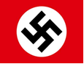

Nation, Leader, Government, Flag | Rise to Power | Characteristics of Government
Soviet Union

Joseph Stalin

Totalitarianism

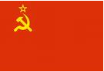
Italy

Benito Mussolini

Fascism

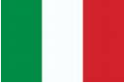
Japan

Hideki Tojo

Militarism

